1. **FIle permission task**

Create a file with .txt extension (/home/demo.txt). Change the permission set of that file, so that any user can read it, group can read/write & owner can read/write/execute it.

1. Login into the server
2. Switch to root user
3. Use “ touch /home/demo.txt” hit enter
4. Then type “cd /home” press enter
5. And then “ls -lah”
6. Here you can see .txt extension (/home/demo.txt)

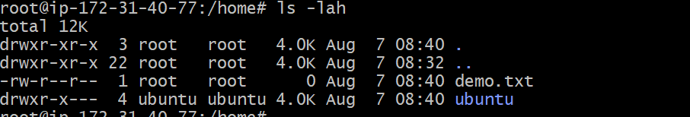

1. go to the home directory .
2. Type “chmod 764 /home/demo.txt”
3. Permission got updated
4. Then “ls-lah” can view the permission of the file



